**NAME**

**COLLEGE NUMBER**

**TASK 1**

**Description of the ERD Diagram**

The ERD diagram shows a simple relationship between the different entities in the description scenario in a match. For example, a tournament can be played in several stadia and each match can also be played in sacral stadia. Coaches can go to several matches and players can also participate in several matches with one team at a time.

**Description of the entities**

Each entity is used a holding set. Players have a unique ID that they can use to participate in any match, match IDs are used to join referees to particular matches, also, a match can be played in many stadia, each stadia, is identified by a stadia ID, and each stadium can accommodate several tournaments, each tournament Is identified by tournament ID. All players can share a tournament.

**Relational model description**

After the ERD, in order to come up with the relational model, attention was given to the child parent inheritance, by observing the linkage between each table, and this was identified by the commonalty of primary key , secondary key inherence. This is what formed the design of the relational model and how each table was going to relate to each other, either as one to many, many to one, one to one or many to many.

**TASK 2**

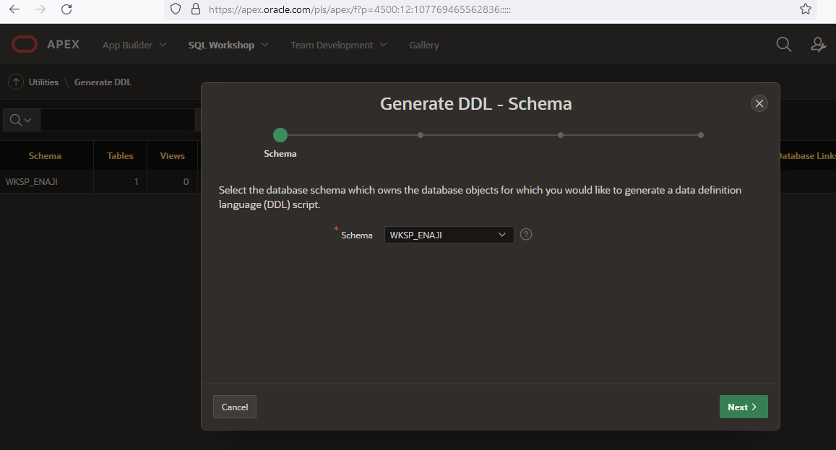

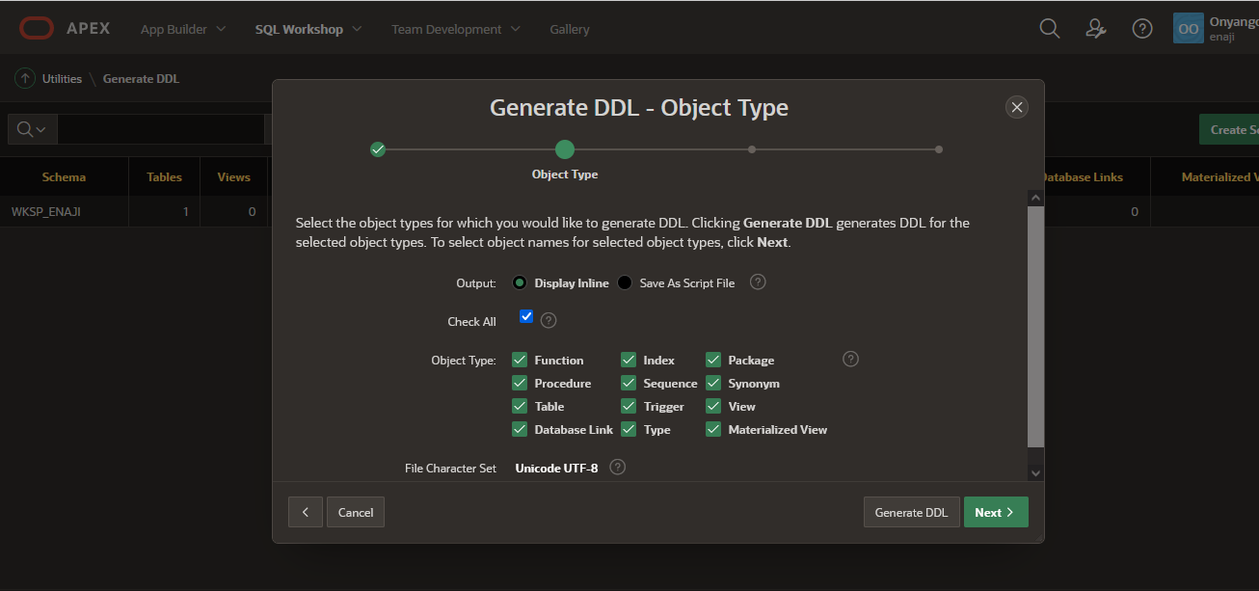

**CREATING THE TABLES**

CREATE TABLE MATCH

(

MATCH_CODE VARCHAR(255) PRIMARY NOT NULL,

MATCH_DATE TIMESTAMP,

NO_OF_PLAYERS INT,

SCORE INT,

PRIMARY KEY (MATCH_CODE),

FOREIGN KEY (REF_ID) REFERENCES REFEREE(REF_ID)

);

CREATE TABLE PLAYERS

(

PASSPORT_NUM VARCHAR(255) PRIMARY NOT NULL,

PLAYER_NAME VARCHAR(255),

MACTH_ID INT,

NATIONALITY VARCHAR(255)

PRIMARY KEY (PASSPORT_NUM),

FOREIGN KEY (MATCH_CODE) REFERENCES MATCH(MATCH_CODE)

);

CREATE TABLE REFEREE

(

REF_ID INT PRIMARY NOT NULL,

REF_NAME VARCHAR(255),

MACTH_ID INT,

NATIONALITY VARCHAR(255)

PRIMARY KEY (PASSPORT_NUM),

FOREIGN KEY (REF_ID) REFERENCES MATCH(MATCH_CODE)

);

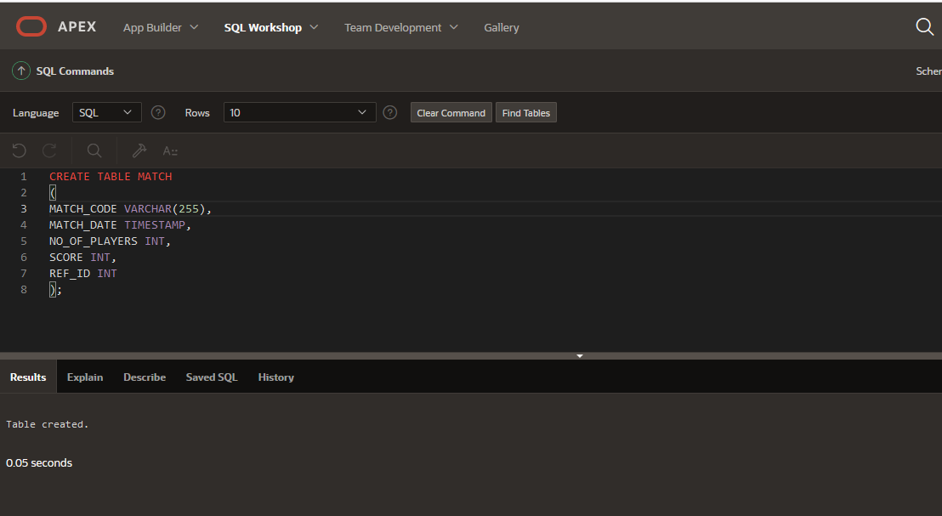

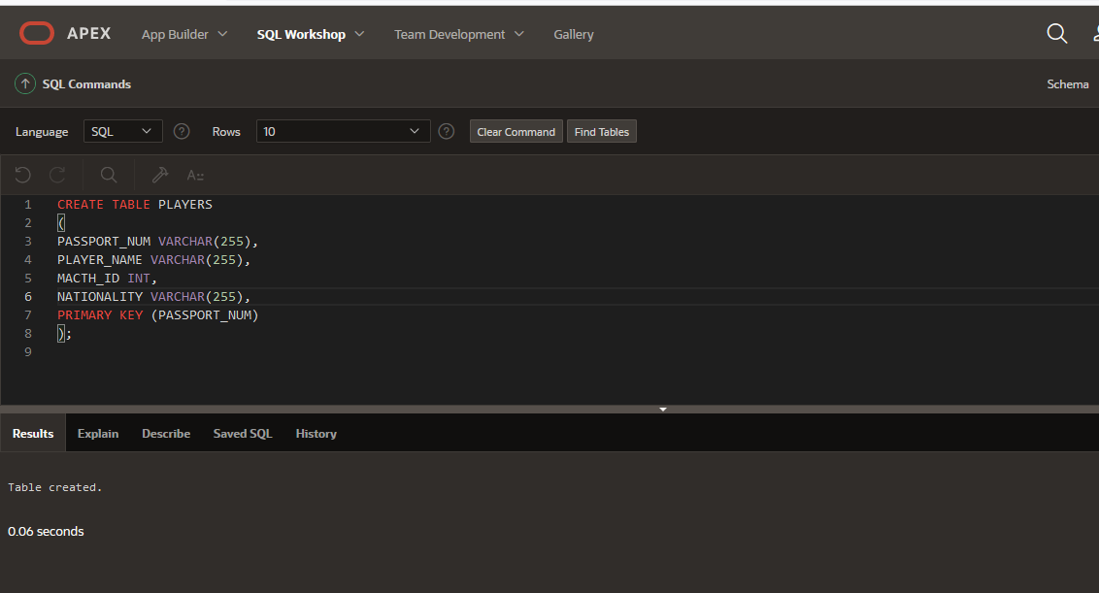

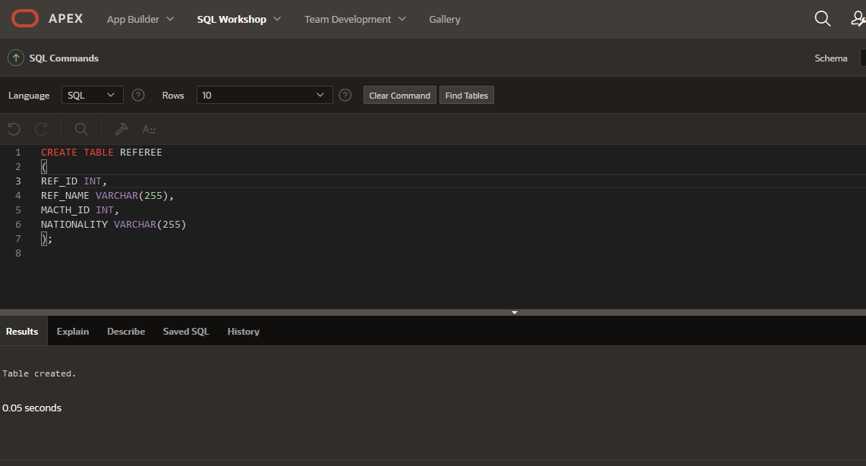

**INSERT RECORDS INTO THE ABOVE TABLES**

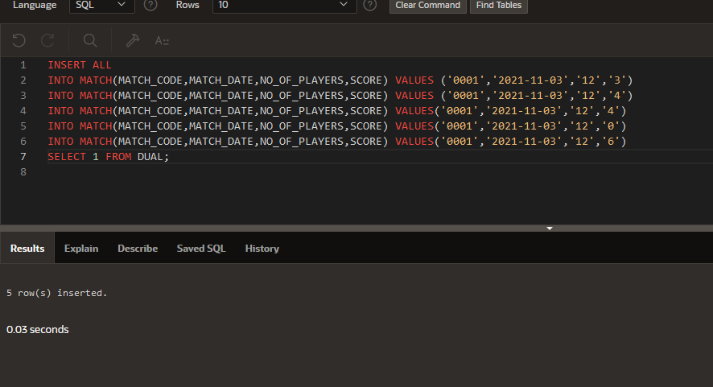

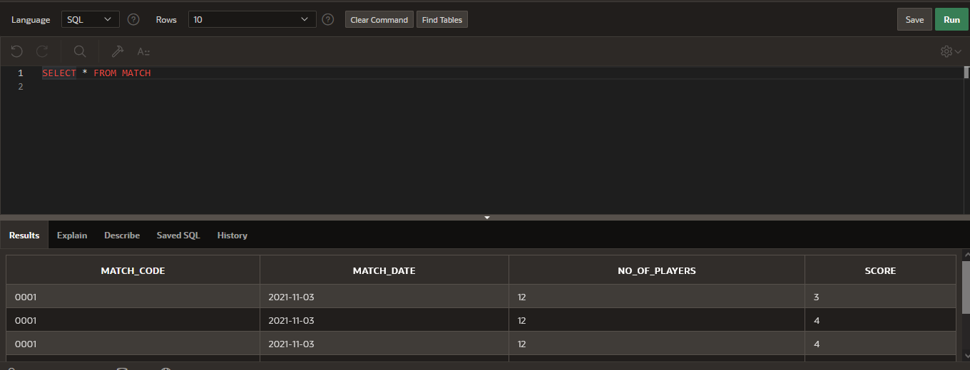

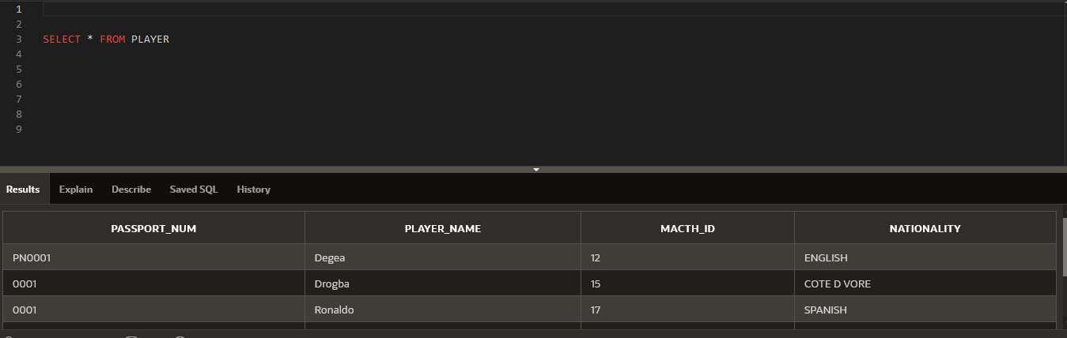

**Question 4 Queries**

1. **Selecting a match where score was 3**

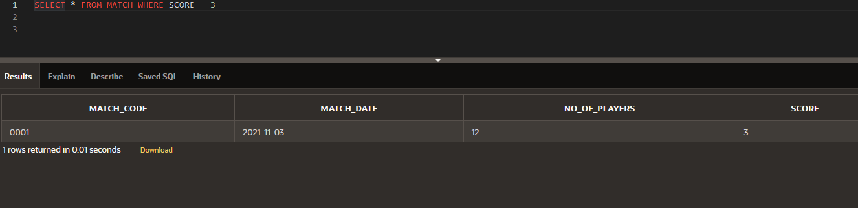

1. **Selecting all matches that were played before 2021 and had scores of greater than 2**

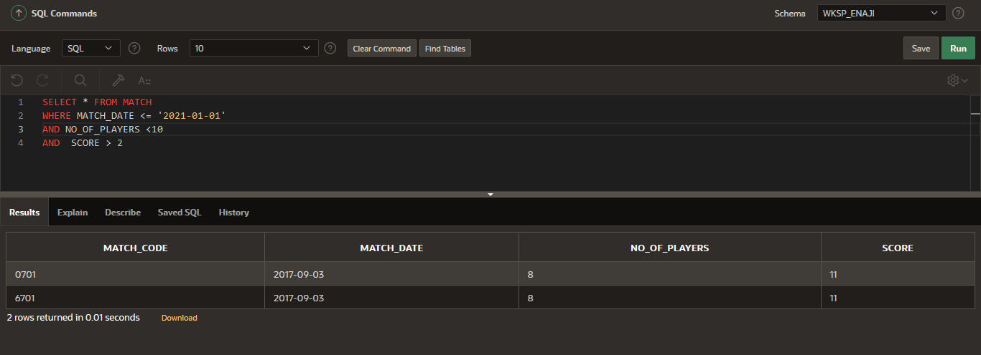

1. **Update the players table match ID to match the correct match ID on the matches table**

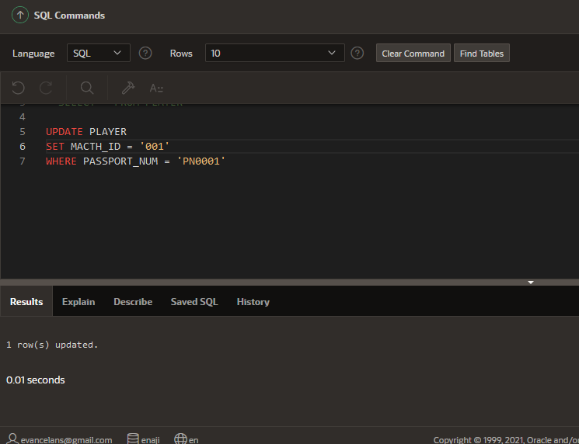

1. **Select the maximum number of scores that each match has ever had**

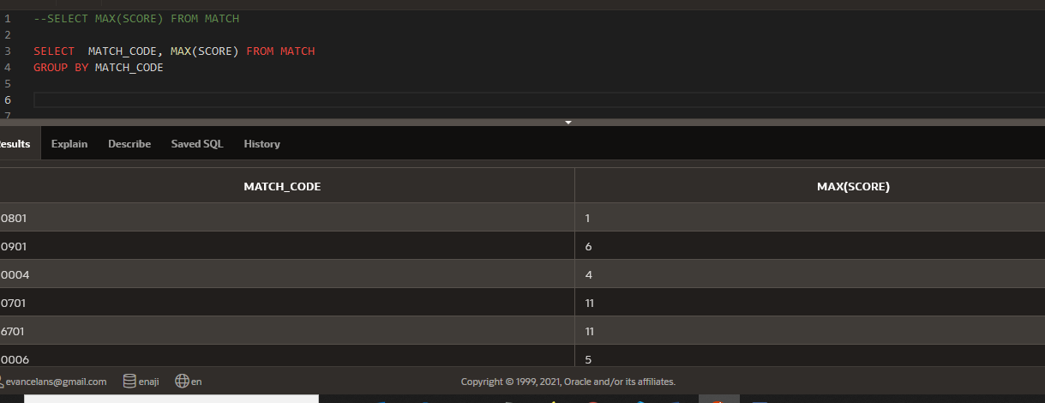

1. **Deleting a match with a duplicate score value**

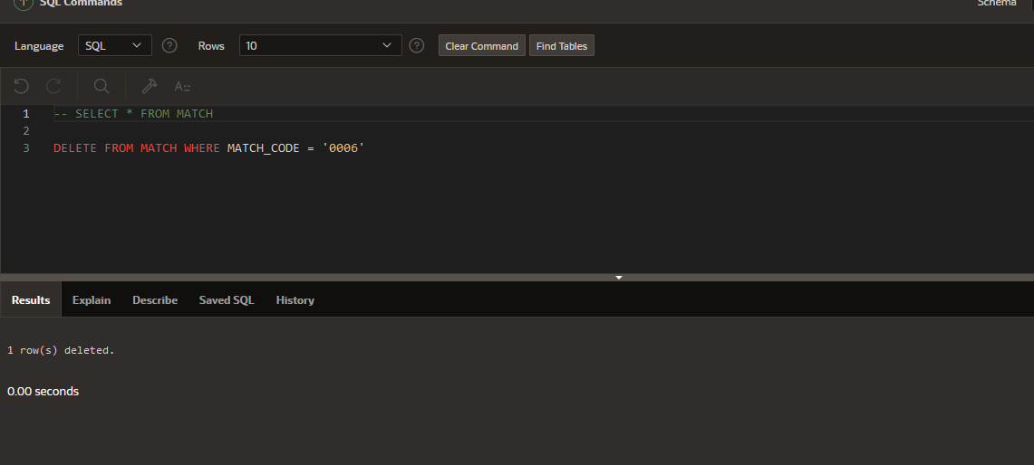

1. **Let’s concatenate the players with a SUPER tag before their names and another tag MARIO for their countries**

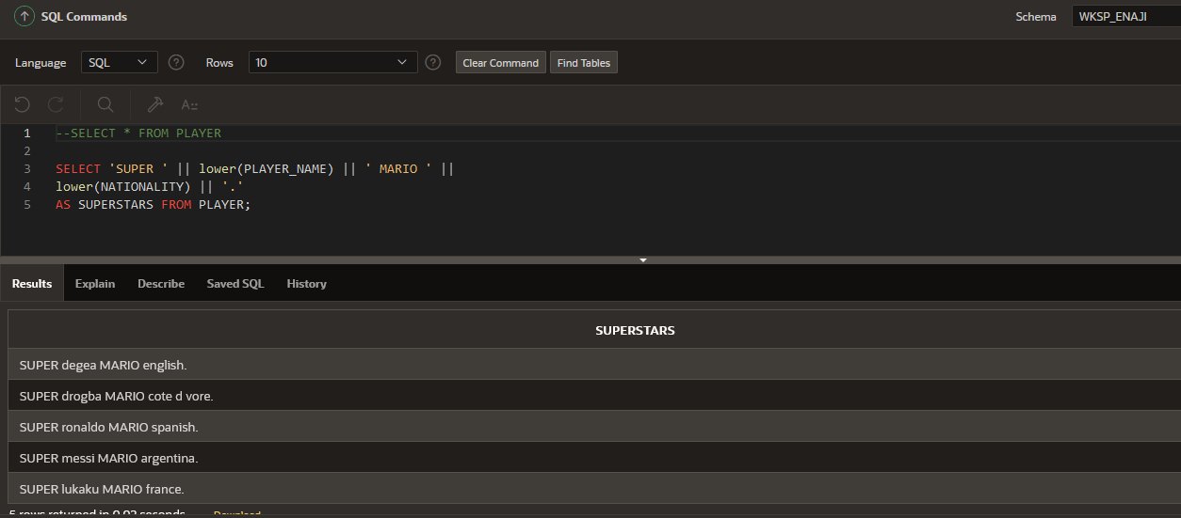

1. **Grouping all players by their nationality against the matches that they have played**

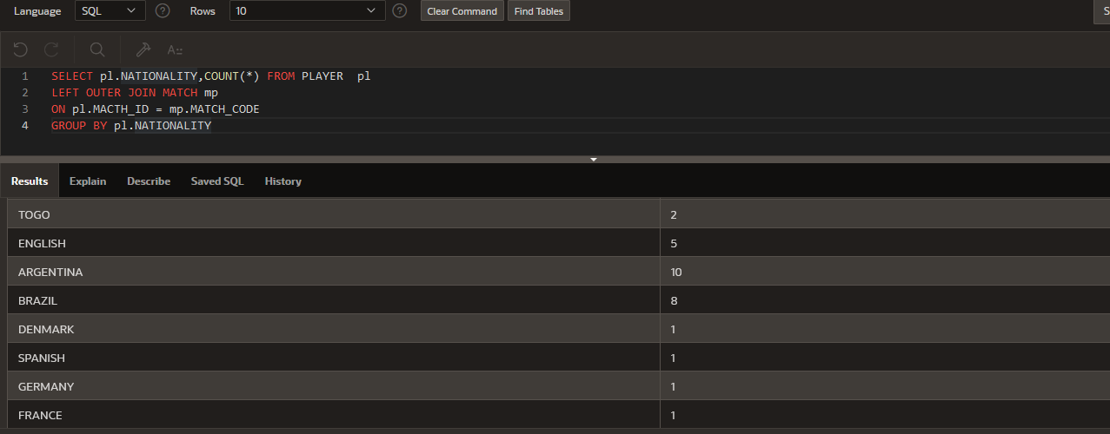

1. **Get the total sum of all goals that have ever been scored by Brazilian Nationals**

